Once you log into my.scouting.org, click on the Safeguarding Youth Training logo.
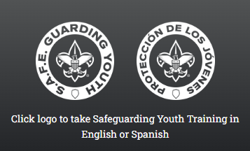
You will be taken to the page for the full 90-minute course for anyone who has not completed it before. This is for new leaders, and those who took Youth Protection Training, but not Safeguarding Youth over the last year.
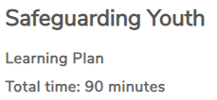
Everyone must complete the 20-minute refresher course this year as well.
To do that, click on catalog at the top of the training page. https://training.scouting.org/home

Enter “safeguarding youth” as your search term
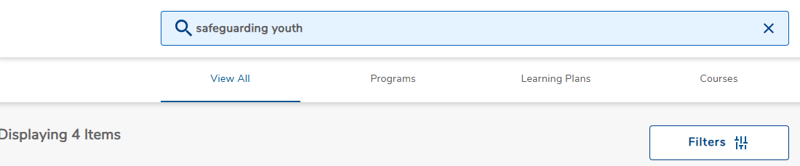

When it displays the 4 results, there should be 2 on the left. Choose the refresher
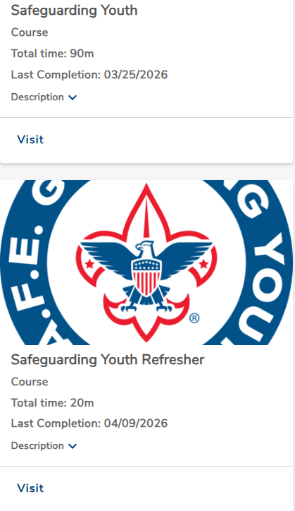

Your profile will update with the new expiration of your Safeguarding Youth Training.
Some people have noted it will not update instantly if the system is busy.
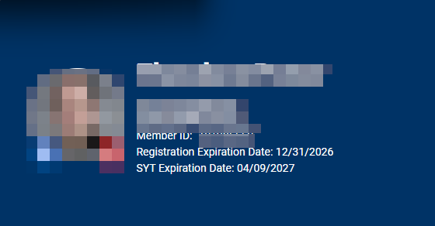

If you have further questions on the training site, contact:
Ted Langdon – ted_langdon@email.com
Kevin Owen – kevin@owenlink.com

