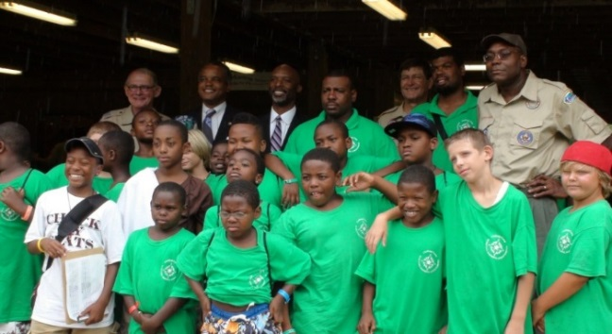
We need you to BECOME A MENTOR!

Challenge Camp is a free character and value building camp offered by Dan Beard Council, BSA for youth ages 8-14 residing in Greater Cincinnati and Northern Kentucky. Our campers are great young people who enjoy the excitement of the outdoors delivered by Scouting and who might not otherwise be able to afford the experience.
Challenge Camp is led by a staff of 35 and various volunteer mentors, just like you, from the community. Mentors provide leadership and encouragement.
As a mentor, you can volunteer for the time that you have. Feel free to pick as little as one day or as many as a whole week.
Session 1 – July 6-10, 2020 (Ages 11-14): 60 mentors needed for this week

Session 2 – July 13-17, 2020 (Ages 8-10): 125 mentors needed for this week
CHALLENGE CAMP is located at Cub World, 6035 Price Rd. Loveland, OH 45140
Buses start arriving at Camp as early as 8:30 a.m., with Camp activities running from 9:30 a.m. – 2:45 p.m.
Responsibilities of a Mentor:
- Participate in daily mentor briefing meetings at 8:30 a.m.
- Take attendance of patrol members daily and guide patrol to and from all daily activities.
- Lead a daily session involving rank advancement.
- Encourage patrol to show Scout spirit by creating a patrol flag, patrol chant, and do their best in all activities.
- Be a positive role model to all campers and most important, HAVE FUN!

To sign-up or for more information:
Email sarah.dods@scouting.org, call (513) 673-3667 or visit
http://www.danbeard.org/become-a-challenge-camp-mentor/

