Boy Scouts of America Invites you to…
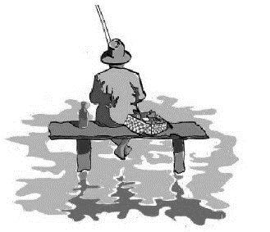
Buzz’s Fishing Derby! May 18th 2019 From 9:30-1:30
-A day of fishing, food and other activities for the whole family - LUNCH IS FREE!!!!!!!!!!
-Wonderful Prizes for fishing contests
-No Cost and free transportation
-Will be located at CAMP FRIEDLANDER,
581 IBOLD Rd. Loveland, OH, 45140
*Registration are limited TO a first come basis* PLEASE RETURN ASAP!!!
Please Return the bottom Part back into School or to your Boy Scout Leader - (BUS STOPS ON BACK OF PAGE)
Scouts Name______________________________________________________ Grade___________
Scouts School_________________________________________________________________________
#Family members coming________ limited to 5 (no bus sits available for family)
Parent/Guardian Name______________________________________________________________
Signature_______________________________________ Phone Number______________________
Parent Email__________________________________________________________________________
Emergency Contact: Name________________________________________________________ph#_______________________
Allergies/Special Needs ______Yes/_____no
Explain_________________________________________________________________________________
I hereby assign and grant to the Boy Scouts of America the right and permission to use and publish the photographs/film/videotapes/electronic representations and/or sound recordings made of me this date by the Boy Scouts of America, and I hereby release the Boy Scouts of America from any and all liability from such use and publication
.I hereby authorize the reproduction, sale, copyright, exhibit, broadcast, electronic storage and/or distribution of said photographs/film/videotapes/electronic representations and/or sound recordings without limitation at the discretion of the Boy Scouts of America and I specifically waive any right to any compensation I may have for any of the foregoing.
For Questions call -or- text: Celeste Moss- 513-659-5056____________________

