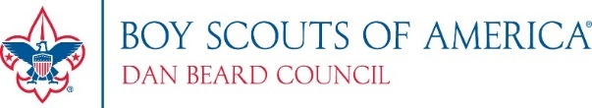
Dan Beard Council, BSA <<date>>
<<Name>> - <<Position - Committee Chair>>
<<Unit Name>>
<<City, State>>
<<Phone Number>>
Dear <<Manager Name>>,
Each year [unit #] of [chartered organization] from right here in our home community of [Community Name] organizes a Popcorn fundraiser to allow Scouts to earn their own way in the Scouting program. [We’ve had the pleasure of selling at your location for the past ___ years and it has been so instrumental to our sale and the local kids in our Pack/Troop/etc.] Our annual popcorn fundraiser is a means for Scouts to be able to reach out to the community, as well as seek support for their activities throughout the year which includes [ _#_ service hours] our unit provides each year. The sale also enables Scouts to develop communication skills, money management, and the confidence necessary to become a future community leader. The popcorn sale allows Scouts to afford camping experiences, uniforms, training and leadership courses, activities and much more to benefit their development.
In past years, our unit has raised significant funds to help support this local youth program which has allowed our kids opportunities that they may not have otherwise been able to partake in. Much of this support and youth development takes place at storefront sales at local establishments like yourself, where Scouts (and supervising adults) setup a small table to ask for support.
We would like to ask for your support in helping our local Scouts by selling popcorn in front of [your business, school, church, etc. name] for a few hours this year. People appreciate giving back to the community and it would help our local Scouts immensely. Can we count on your support?
[Yes - Confirm specific requested dates and times or timeframe].
We’ll of course be sure to follow any rules you have in place and to properly clean our space before we leave.
Thank you so much. The strength of our Scouting program is reflective of the investment of time, talent and treasure from our local Scouting community. Thank you again for your community support. If you have any questions regarding our Popcorn sales please feel free to contact [kernel name], at [phone/email]. Thank you for supporting Scouts!
Yours in Scouting,
[name]
[unit] – [chartered organization]
[phone]
[email]

